# Universes

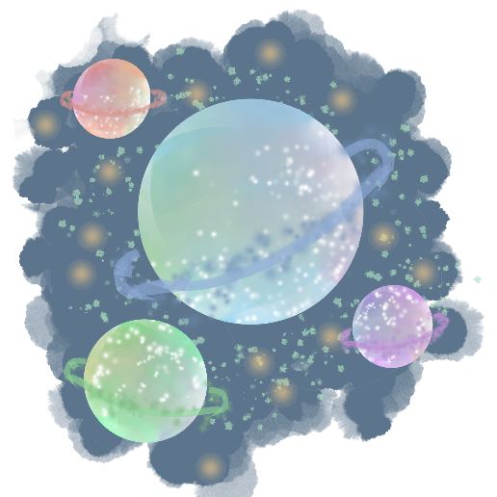

There are n planets. Some of them are connected, while some are not. If planet a is connected directly with planet b, and planet b is connected directly with planet c, then planet a is connected indirectly with planet c.

A universe is a group of directly or indirectly connected planets and no other planets outside of the group.

Write a program that prints the **total number of universes**.

## Input

* On the first line you will receive an integer – l – number of lines.
* On the next l lines, you will receive a list in the following format: "{planet1} - {planet2}".
  + This means that **planet1 and planet2 are** **connected**.

## Output

* Print the **total number of universes**.

## Constraints

* Number of planets will be in the range [1… 20].
* Number of lines will be in the range [1… 100].

## Examples

|  |  |
| --- | --- |
| **Input** | **Output** |
| 5  Mercury - Mars  Mars - Saturn  Saturn - Venus  Dibiasky - Arion  Dimidium - Galileo | 3 |